PICKENS SCHOOL PBIS RECOGNITION PROGRAM

The students at Pickens School have been learning about school-wide behavioral expectations. These expectations have been generated by students and agreed upon by staff as an effective way to be proactive in managing behaviors. Each area of our school has its own set of expectations. The following information shows the expectations along with what the particular behaviors should look like in all school settings. The students focused on describing what Safety, Responsibility, and Respectability looks like in a variety of school settings: bus, cafeteria, classroom, hallway and the gym.

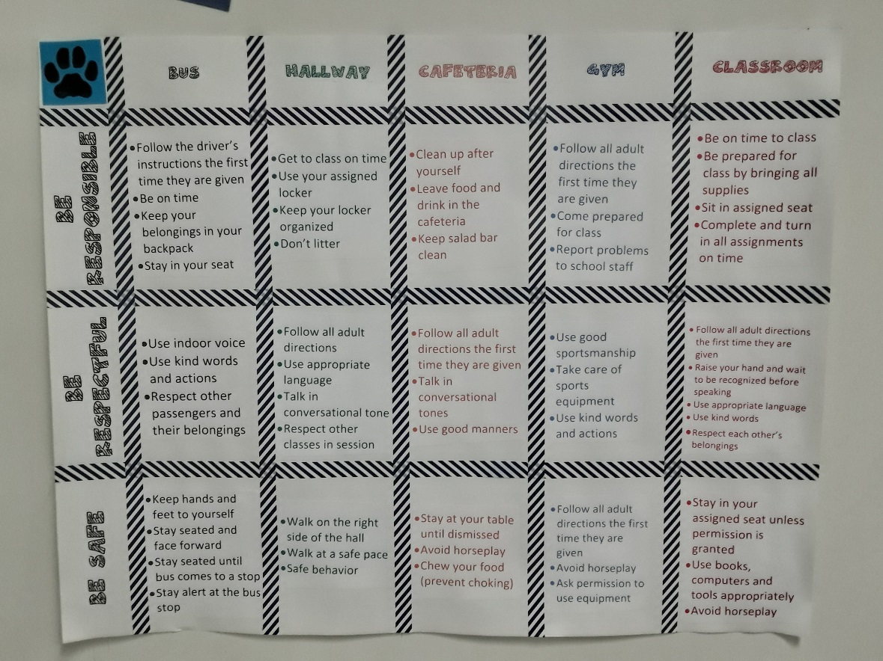

This approach to managing behaviors is a positive one. Students are acknowledged for exhibiting the behaviors that are expected by participating in quarterly Positive Behavior reward activities. These will include, in school activities, reward trips, and other recognition activities. In addition, behavior that is above and beyond expected behaviors, selected students receive a “Panther Paw”. These Paws are drawn at the end of each month and the selected student receives a reward for their exceptional behavior.

